CHANGES

CHANGES- WHICH I EXPERIENCED
I born In Akola Maharashtra , One Of The Well Known State Of India ,Often I Feels Lucky And Fortunate For Being Born In Maharashtra (Ofcourse For Being Indian) And Always Try To Learn Much And Most From Surrounding Due To Its Well Cultured People And Enriched Nature Also Fascinates By Seeing Different Language Speaking People’s From All Over India And Tries To Learn From It.
AS My Great Grandfather Was North-Indian And Had Land And Great Horticulture Area Under In His Administration So I Has Access To Experience All Those Things Too, Which Other North-Indian Children’s Had .
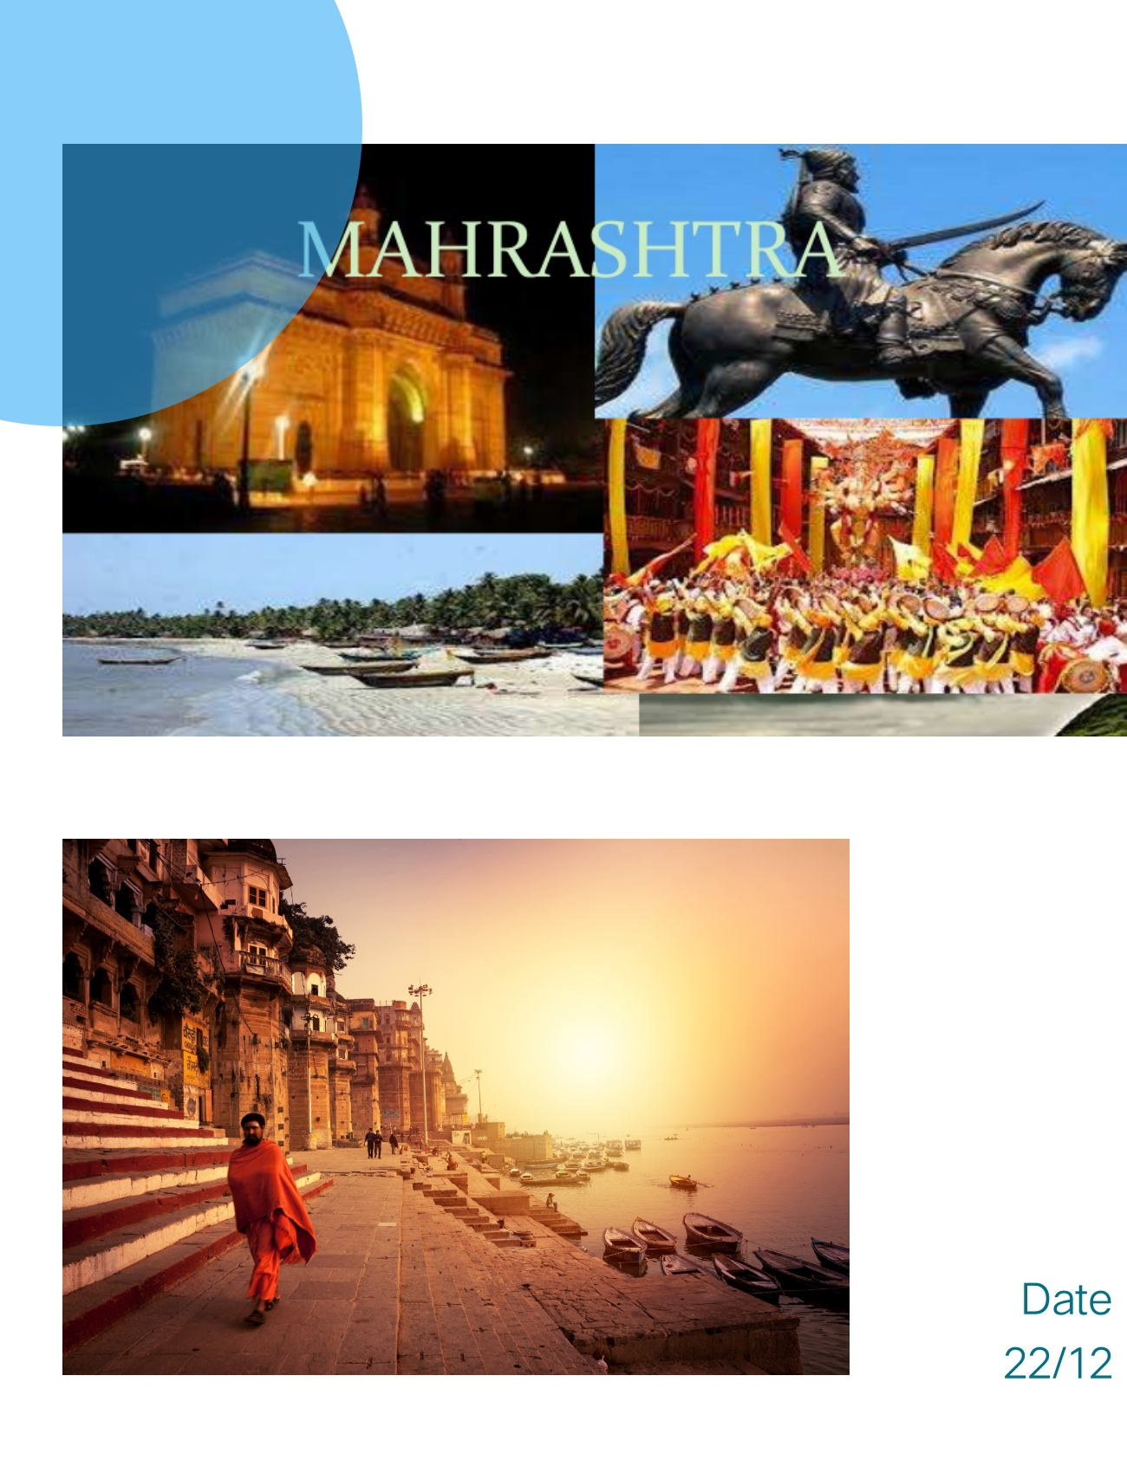
I Excites Much More When Thinks-off About Joys ,Happiness , About Each And Every Moment What I Experienced By Visiting Various Temples, Bagh , Markets Having Old Barter System Of Economy Which Gives The Feel Of Living History In Modern .
Having Relation With Two States At A Time Inculcated The Pure Indian Character And Love In My Soul And Hence I Gives Priority To Motherland (Country) In Any Situation .

-DHIRENDRA .H. TIWARI
(TWO STATES – SERIES PART:-1}

